St. Cuthbert’s Catholic Primary School
Special Educational Needs and Disability (SEND) Information Report 2025

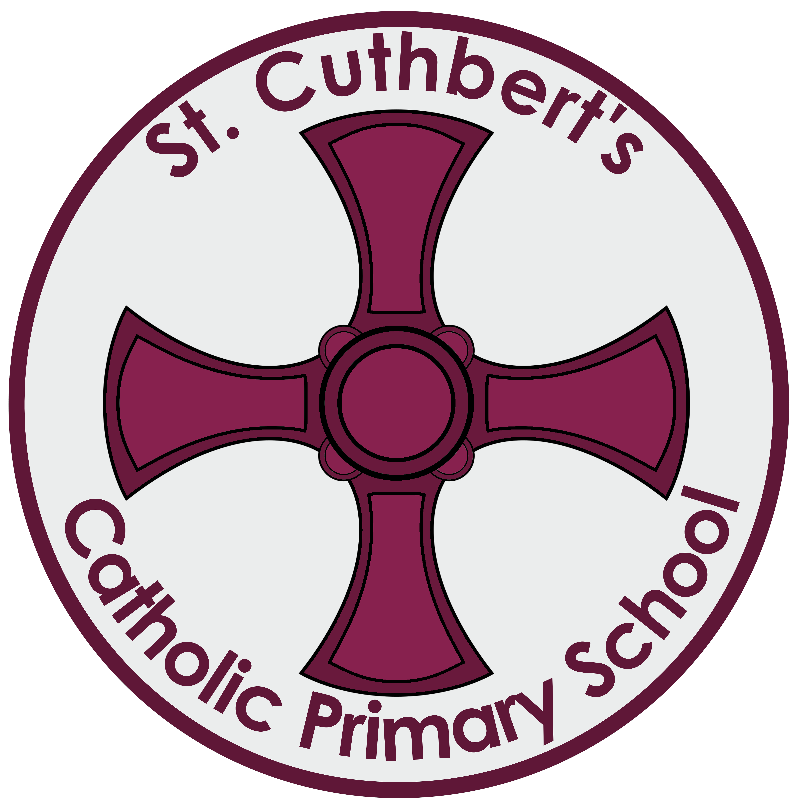

Approved by: | Nicola Noble | Date: 8.10.25
Last reviewed on:
Next review due by: | September 2026

School ethos and approach:

We at St. Cuthbert’s Catholic Primary School are committed to meeting the special educational needs of children enabling them to achieve their very best. In line with our mission statement, where Christ is our inspiration, children can feel valued, confident and secure. We believe that each person is unique, talented and loved by God. As a school, we aim to create a challenging, stimulating and effective learning environment where children with SEN have their particular needs recognised, enabling them to achieve success.
We understand that it can be a difficult time for parents/carers and families in the early stages of identifying a child with additional needs. We aim to reassure and support parents/carers throughout the SEN process. Parents hold key information and knowledge about their child, which is integral to the contribution in their child’s learning. We will always keep parents/carers informed about their child’s additional needs and will invite then to review meetings.

This document outlines the variety of ways we ensure we support our children with SEND (Special Educational Needs and/or Disabilities) to achieve their potential. It outlines the skills, resources and techniques that we currently use to provide a full range of educational and pastoral support for all of our children. This continues to be developed and modified to meet the changing requirements of each individual child, allowing them to receive a unique provision.

Definition of SEN:
A child or young person has SEN if they have a learning difficulty or disability which calls for special educational provision to be made that is additional to or different from that made generally for other children or young people of the same age. (Code of Practice 2015, p16)

Broad areas of need:
There are four broad areas of special educational need, these are:

Communication and Interaction
Includes pupils with Autism Spectrum Condition and those with Speech, Language and Communication Needs.

Cognition and Learning
Includes pupils with Specific Learning Difficulties, Moderate Learning Difficulties, Severe Learning Difficulties and Profound and Multiple Learning Difficulties.

Social, Emotional and Mental Health Difficulties
Includes any pupils who have an emotional, social or mental health needs that is impacting on their ability to learn.

Sensory and/or Physical Difficulties
Includes pupils with hearing impairment, visual impairment, multi-sensory impairment and physical difficulties.

Arrangements for the Admission of Pupils with Disabilities

The admission of pupils with disabilities is considered in the first instance in the same way as non-disabled pupils. Further considerations are made in the light of need and accessibility. Steps are taken to prevent any pupil being treated less favourably than others. In practice we ensure that classroom and extra-curricular activities encourage the participation of all pupils, including those with Special Educational Needs. Staff organise human and physical resources within the school to increase access to learning and participation for all pupils.

Information:
If you need any information regarding SEN please feel free to contact the SENCO, Mrs. Susan Lambert or the Headteacher Mrs. Nicola Noble on 01915813090 or alternatively email the school on office@stcuthbertsprimary.com
In addition, our school SEND link governor, Kelly Lammond, is contactable via school.

The SEN information report is reviewed annually. The next review will be September 2026.

https://www.stcuthbertsprimary.com/policies/

This link will take you to the website where you can find the following policies:

- Admissions Policy 2024-2025
- Accessibility Policy and Plan
- Attendance Policy
- Equality Policy
- Safeguarding & Child Protection Policy 2024-2025
- Safeguarding Guidance: A response to Covid-19
- SEND Policy

SEN Provision:

At St. Cuthbert’s Catholic Primary School we have children with a range of needs. We have children who have communication and interaction needs, cognition and learning needs, sensory and physical needs and social, emotional and mental health needs. Children who are identified as having a need are supported by staff in their classes and by the SENCO. The current SEN register is 18% (EHCP and SEN support combined) just below the national average of 19.4% (EHCP and SEN support combined).

At St. Cuthbert’s Catholic Primary School we work hard to ensure all children with SEN are supported regardless of level of need.
We do this through a variety of ways such as 1:1 and small group intervention support. We provide support using a variety of resources depending on need. If children require intervention other than that given in the classroom setting, our teaching assistants work with small groups for bespoke intervention.

Adapting the curriculum:

To ensure all children can access the curriculum and have the correct support we take advice from external agencies. They may advise to adapt learning in a variety of ways such as:

- Using laptops or I pads to help children complete work
- Sensory breaks worked into the timetable
- Sensory toys to help regulation
- Using visual timetables
- 1:1 support to access activities
- Interventions supporting social skills
- Plus 1 – which is a coaching system for maths success
- Colourful semantics
- Precision teaching
- Intensive Interaction
- BSL

Identifying children with SEN:

Most children in school will have their needs met through good classroom practice. This is called Quality First Teaching.
Where a child is identified as having a special educational need we follow a graduated approach, which takes the form of cycles of “Assess, Plan, Do, Review”.

Assess a child’s special educational needs – This would include assessment by teachers supported by the SENCO, observations and assessments carried out by the educational psychologist and advice from outside agencies.
Plan the provision to meet your child’s aspirations and the class teacher plans agreed outcomes – Additional or different provision is planned by the class teacher with the support from the SENCO and external advice where it has been requested. Targets are set and formalized in a short note, a support plan or an EHCP and are discussed with parents/carers and the child.
Do put the provision in place to meet those outcomes – Interventions are put in place and time and support is allocated for them to be carried out.
Review the support and progress – The impact of any intervention is reviewed with teachers, parents/carers and the child looking at progress towards targets and next steps.

As part of this approach each child with SEN will have an individualised short note or SEN Support Plan that describes the child’s needs, outcomes & provision to meet those needs. Parents/carers views are integral to the process.

Short notes and SEN Support Plans are updated 3 times a year October, February and June. Parents are invited to review meetings to discuss and review plans with teaching staff.

When writing a support plan, we take into account how the curriculum and environment may need adapting in order for the child to succeed. This can be done in a variety of ways such as:
Quantity. The number of items or activities the pupil is expected to complete.
Time. We sometimes need to change the time allowed for learning, task completion or testing.
Level of Support. This may increase or decrease depending on need.
Method of Instruction. This may be a multi-sensory approach: visuals, hands on materials, enlarge text, concrete examples.

A small percentage of children with more complex needs may require an assessment that could lead to an Educational, Health and Care Plan.

Education, Health and Care assessment:

The majority of children and young people with SEN or disabilities will have their needs met within local and mainstream early years settings. schools or collages. Some children and young people may require an EHC needs assessment in order for the local authority to decide whether it is necessary for it to make provision in accordance with an EHC plan.

The purpose of the EHC plan is to make special educational provision to meet the special educational needs of the child or the young person, to secure the best possible outcomes for them across education, health and social care and, as they get older, prepare them for adulthood. To achieve this, local authorities use the information from the assessment to:

- establish and record the views, interests and aspirations of the parents and child or young person

- provide a full description of the child or young person’s special educational needs and any health and social care needs

- establish outcomes across education, health and social care based on the child or young person’s needs and aspirations

- specify the provision required and how education, health and care services will work together to meet the child or young person’s needs and support the achievement of the agreed outcomes (SEN Code of Practice 2015, P142)

For more information you can look at the local offer at:
http://www.countydurhamfamilies.info/kb5/durham/fsd/localoffer.page

Evaluating the effectiveness of SEN provision:

Here at St. Cuthbert’s Catholic Primary School, we continuously ensure that provision has a positive impact on the outcomes for all pupils. We do this in a variety of ways including

- Book scrutinies
- Termly SENCO/SLT/Governor meetings.
- Learning walks
- Monitoring of interventions.

Support for Emotional & Social Development:

Mrs Donnelly, one of our HLTA’s is our Emotional Wellbeing Coordinator and she oversees the arrangements for supporting children and young people with their social and emotional development. Support is given through a variety of interventions. These may be as part of a whole class, small group intervention or 1:1.

- Listening Matters (Connecting With Children) - a talking intervention based on the person centered approach. Delivered on a 1:1 basis by a trained practitioner. This intervention can be done on children of any age. It can be done with SEND children, although it is not recommended for children with ASD.

- Lego Therapy - a social development programme usually performed in a small group and supervised by a trained member of staff. It has been used successfully in our school with children on the Autistic Spectrum but can be used with children of all needs and ages.

- Drawing For Talking - An intervention done on a 1:1 basis with a trained member of staff. The purpose is for children to explore their worries and anxieties through drawing and carefully posed questioning.

Measures to prevent bullying

- St Cuthbert’s is an anti-bullying school. We have taken part in the All Together Programme run by the Anti-Bullying Alliance and achieved the Gold Award.

- Our anti-bullying policy is updated regularly and is linked to the SEND policy.
- Older children are trained as Anti-bullying ambassadors and this training includes recognising how and when children with SEND may be vulnerable.
- Children are made aware of bullying during Anti-Bullying Week, activities, assemblies and competitions that happen throughout the year. All children are given information on how to recognise and report bullying.

If you would like any more information about support for Social and Emotional Development, please get in touch with Mrs Donnelly.
Transition:
Children and young people with SEN can be particularly anxious about starting school or moving on to a new class. To reduce anxieties and ensure consistency of support:

Our transition process starts in Reception class. In the summer term, Mrs Wilkinson our Reception class teacher visits children in nursery. Parents are invited in to Reception with their child where the children can stay and play. Mrs Wilkinson also meets with parents to gather information about their child to ensure transition from Nursery to Reception is as seamless as possible.

Moving from Reception to KS 1 and from KS1 to KS2 can be a little daunting. We make this easier by having transition visits in the summer term. The children visit their new class and stay for the afternoon. If a child has additional needs, they may need extra transition visits. Staff from each class work closely together to enable smooth transitions.
If children are still feeling a little anxious, we send home transition booklets. These have pictures of the child’s new teacher, TA, class etc. It explains a little more about what can be expected when the child moves from one class to another. We have found that this is a really useful tool for children and parents to refer to during the holidays.

From primary to secondary can seem incredibly daunting for any child but especially some of our children with SEN, this means it is vital that we have excellent links with our secondary schools. Children with SEN are offered extra transition visits to the secondary school and these can be done with our staff if needed. Meetings with the current class teacher, SENCO and the SENCO from the secondary school are planned so information can be shared to ensure a smooth transition.

If you would like to discuss your SEND needs regarding transition please do not hesitate to get in touch.

Agencies and Partnerships:

To support children with SEND we work closely with a range of agencies including:

- Communication and interaction Team
- Cognition and Learning
- EWEL
- Child and adolescent mental health services (CAMHS)
- Durham Movement Difficulties
- Health Agencies
- Looked After Children
- Medical Practitioners
- One Point Children’s Service
- Social Care and Health
- Specialist Therapists – Occupational Therapy & Physiotherapy
- Sensory – Hearing and Vision Support
- Speech and Language Therapy
- Educational Psychologist
- Education welfare officers
- Road Centre Counseling

Compliments, Complaints and Feedback:

Should you be happy with the provision your child receives, please let the school staff know. It is nice to know that we are making children and parents/carers happy with support we provide!
If you are unhappy, please speak to Mrs Lambert (SENCO), Mrs Noble (Head Teacher) or Mrs Parlett (Deputy Head Teacher) as soon as a problem arises and we will do our best to rectify the problem, in partnership with you and your child. There is also a copy of our school’s complaints procedure on our school website should you feel you require it.

