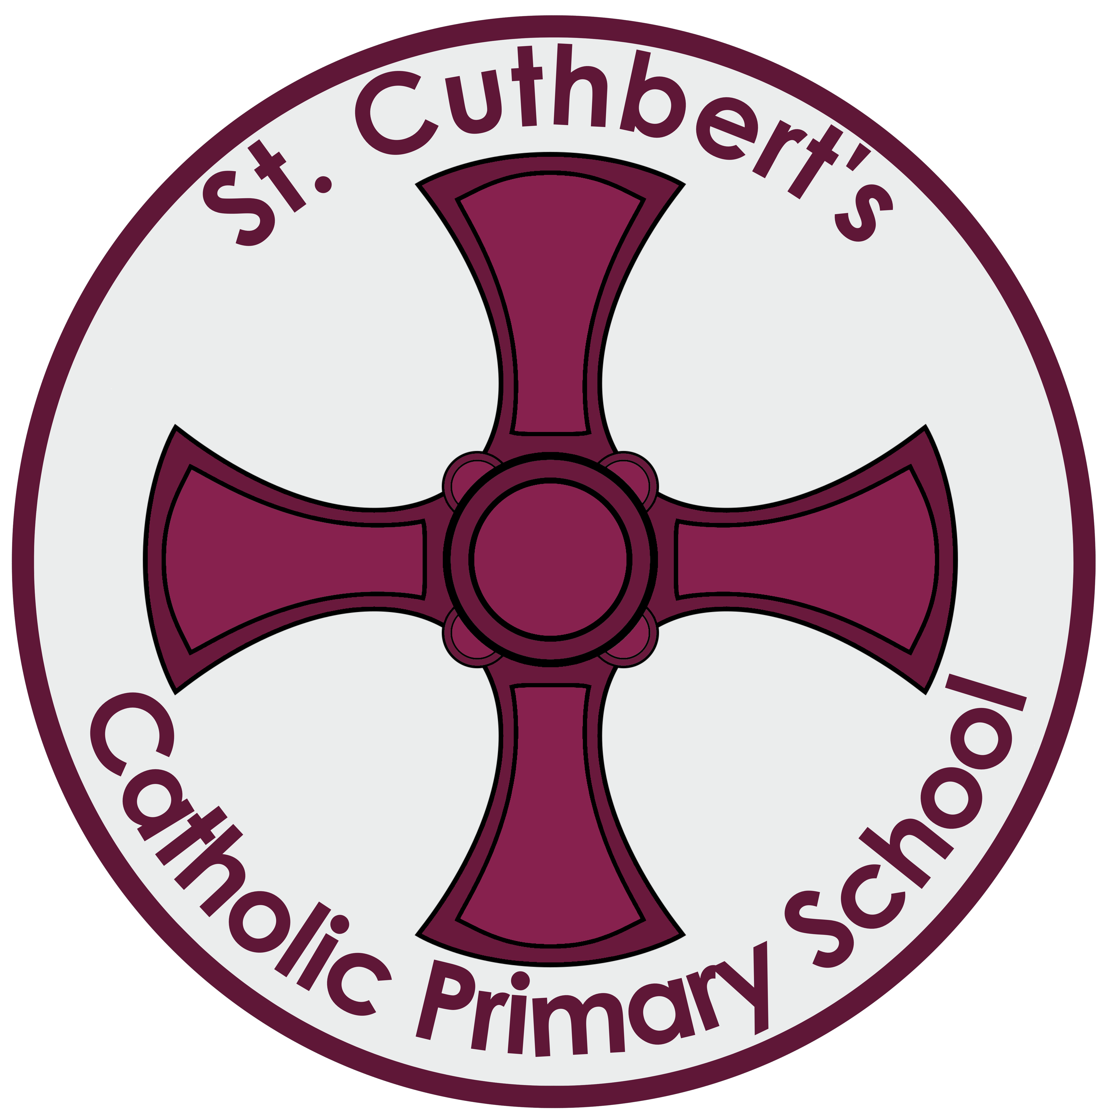

A Statement of British Values

At St Cuthbert’s School we want our children to become, global citizens who are proud of who they are, respectful and tolerant towards others and know their responsibilities to others.
Our Collective Worship programme Nurturing Human Wholeness deepens our pupils understanding of spiritual, moral, social and cultural development. Over the course of the school year pupils;

- are encouraged to be reflective about their own and others’ beliefs
- develop an understanding about themselves and others in the world
- recognise the difference between right and wrong and the importance of tolerance and respect for everyone
- understand the consequences of their behaviour and actions, and appreciate the viewpoints of others
- are supported in, developing a respect for the civil and criminal law of England
- develop their social skills to embrace pupils from different religions, ethnic and socioeconomic backgrounds

In addition to this, our RE and wider curriculum supports pupils in embedding these values (these include a study of other religions, visits to places of worship, global diversity and pupil voice).

Democracy:
Our school working towards becoming a Rights Respecting School, and as such children devise their class, playground, dining room and toilet charters. In addition to this our school council ensures pupils’ voices are heard. The class representatives raise pertinent issues and report back to their classes. Our School Council decide the charities we support and identify ways in which we can do this. They also provide valuable ideas to improve the school environment. Our pupil questionnaires provide further information from pupils which the school acts upon. In this way we teach our children how they can influence decision making through a democratic process. They are encouraged to be involved in the decision-making processes. Children have a broad general knowledge of, and promote respect for, public institutions and services. Within school pupils are provided with platforms to express their views e.g. discussing current topics in assembly and class debates. Through class debates we model how perceived injustices can be peacefully challenged.

The Rule of Law:
The importance of civil and criminal law is explored through history or enrichment activities. Visits by the local police and other services help our children to understand how these services operate and how they support them and their families and how if necessary they hold people to account. Our pupils benefit from a range of visits during their time at St Cuthbert’s;
- from community police officers who discuss road safety, stranger danger
- fire officers
- Child line and community e-safety officers who have strengthened our pupils understanding of how to be safe on line.
- The school routinely offers advice to parents re incidents concerning e-safety outside school. .

Pupils support the local community;
- Choir Singing at church and other important occasions such as Remembrance ceremony to mark 100 years of the First World War

Our pupils enrich and understand the importance of looking after their local community.

The pupils’ charters are clear and fair – they are devised by the pupils and adults adhere to their part of the charter. This ensures that if children make the wrong choices, they understand why this is the wrong choice and the importance of making amends.
Individual Liberty:
Within our school, children are encouraged to make personal choices in a safe and supportive environment. We support our children to develop self-knowledge; self-esteem and self-confidence in all we do. As we are working towards being a Rights Respecting school, children are aware of their rights and personal freedom and the responsibility we must all take for our actions, e.g. through e-safety children are given the ability to make informed safe personal choices. Through the curriculum, children have the opportunity to debate a topic and exercise their right to freedom of speech. During assemblies and through our SMSC curriculum we challenge stereotypes. Children are able to share their concerns informally by using the worry boxes and playground buddies, or contacting the Bully Busters in school or via the school website.

Mutual Respect
The core value of our school ethos is ‘respect’ for ourselves; each other and our environment. Nurturing Human Wholeness provides a platform for children, providing them with a statement to live by, a context for this statement that makes sense to the child, and a challenge to live out this statement in their daily lives.

Tolerance of those of Different Faiths and Beliefs:
Our school community lives and works harmoniously; we welcome pupils from other Christian denominations, other Faiths and those who have no Faith. We consider that our socio-economic and faith diversity enhances our school and deepens our understanding of others. Within school we focus on enhancing our pupils’ knowledge and understanding of their place and the place of others in our culturally diverse society.

We do this by giving them opportunities to positively experience diversity, e.g. by celebrating and sharing our different faiths and cultures, visits we make to other faith places of worship and through our geography curriculum. Our extensive local, European and international links support this. Through our PSCE and SRE curriculum and focus on equality we discuss differences between people; such as faith; ethnicity; disability; gender or sexuality and different family situations so we can encourage critical personal thinking and tolerance.

