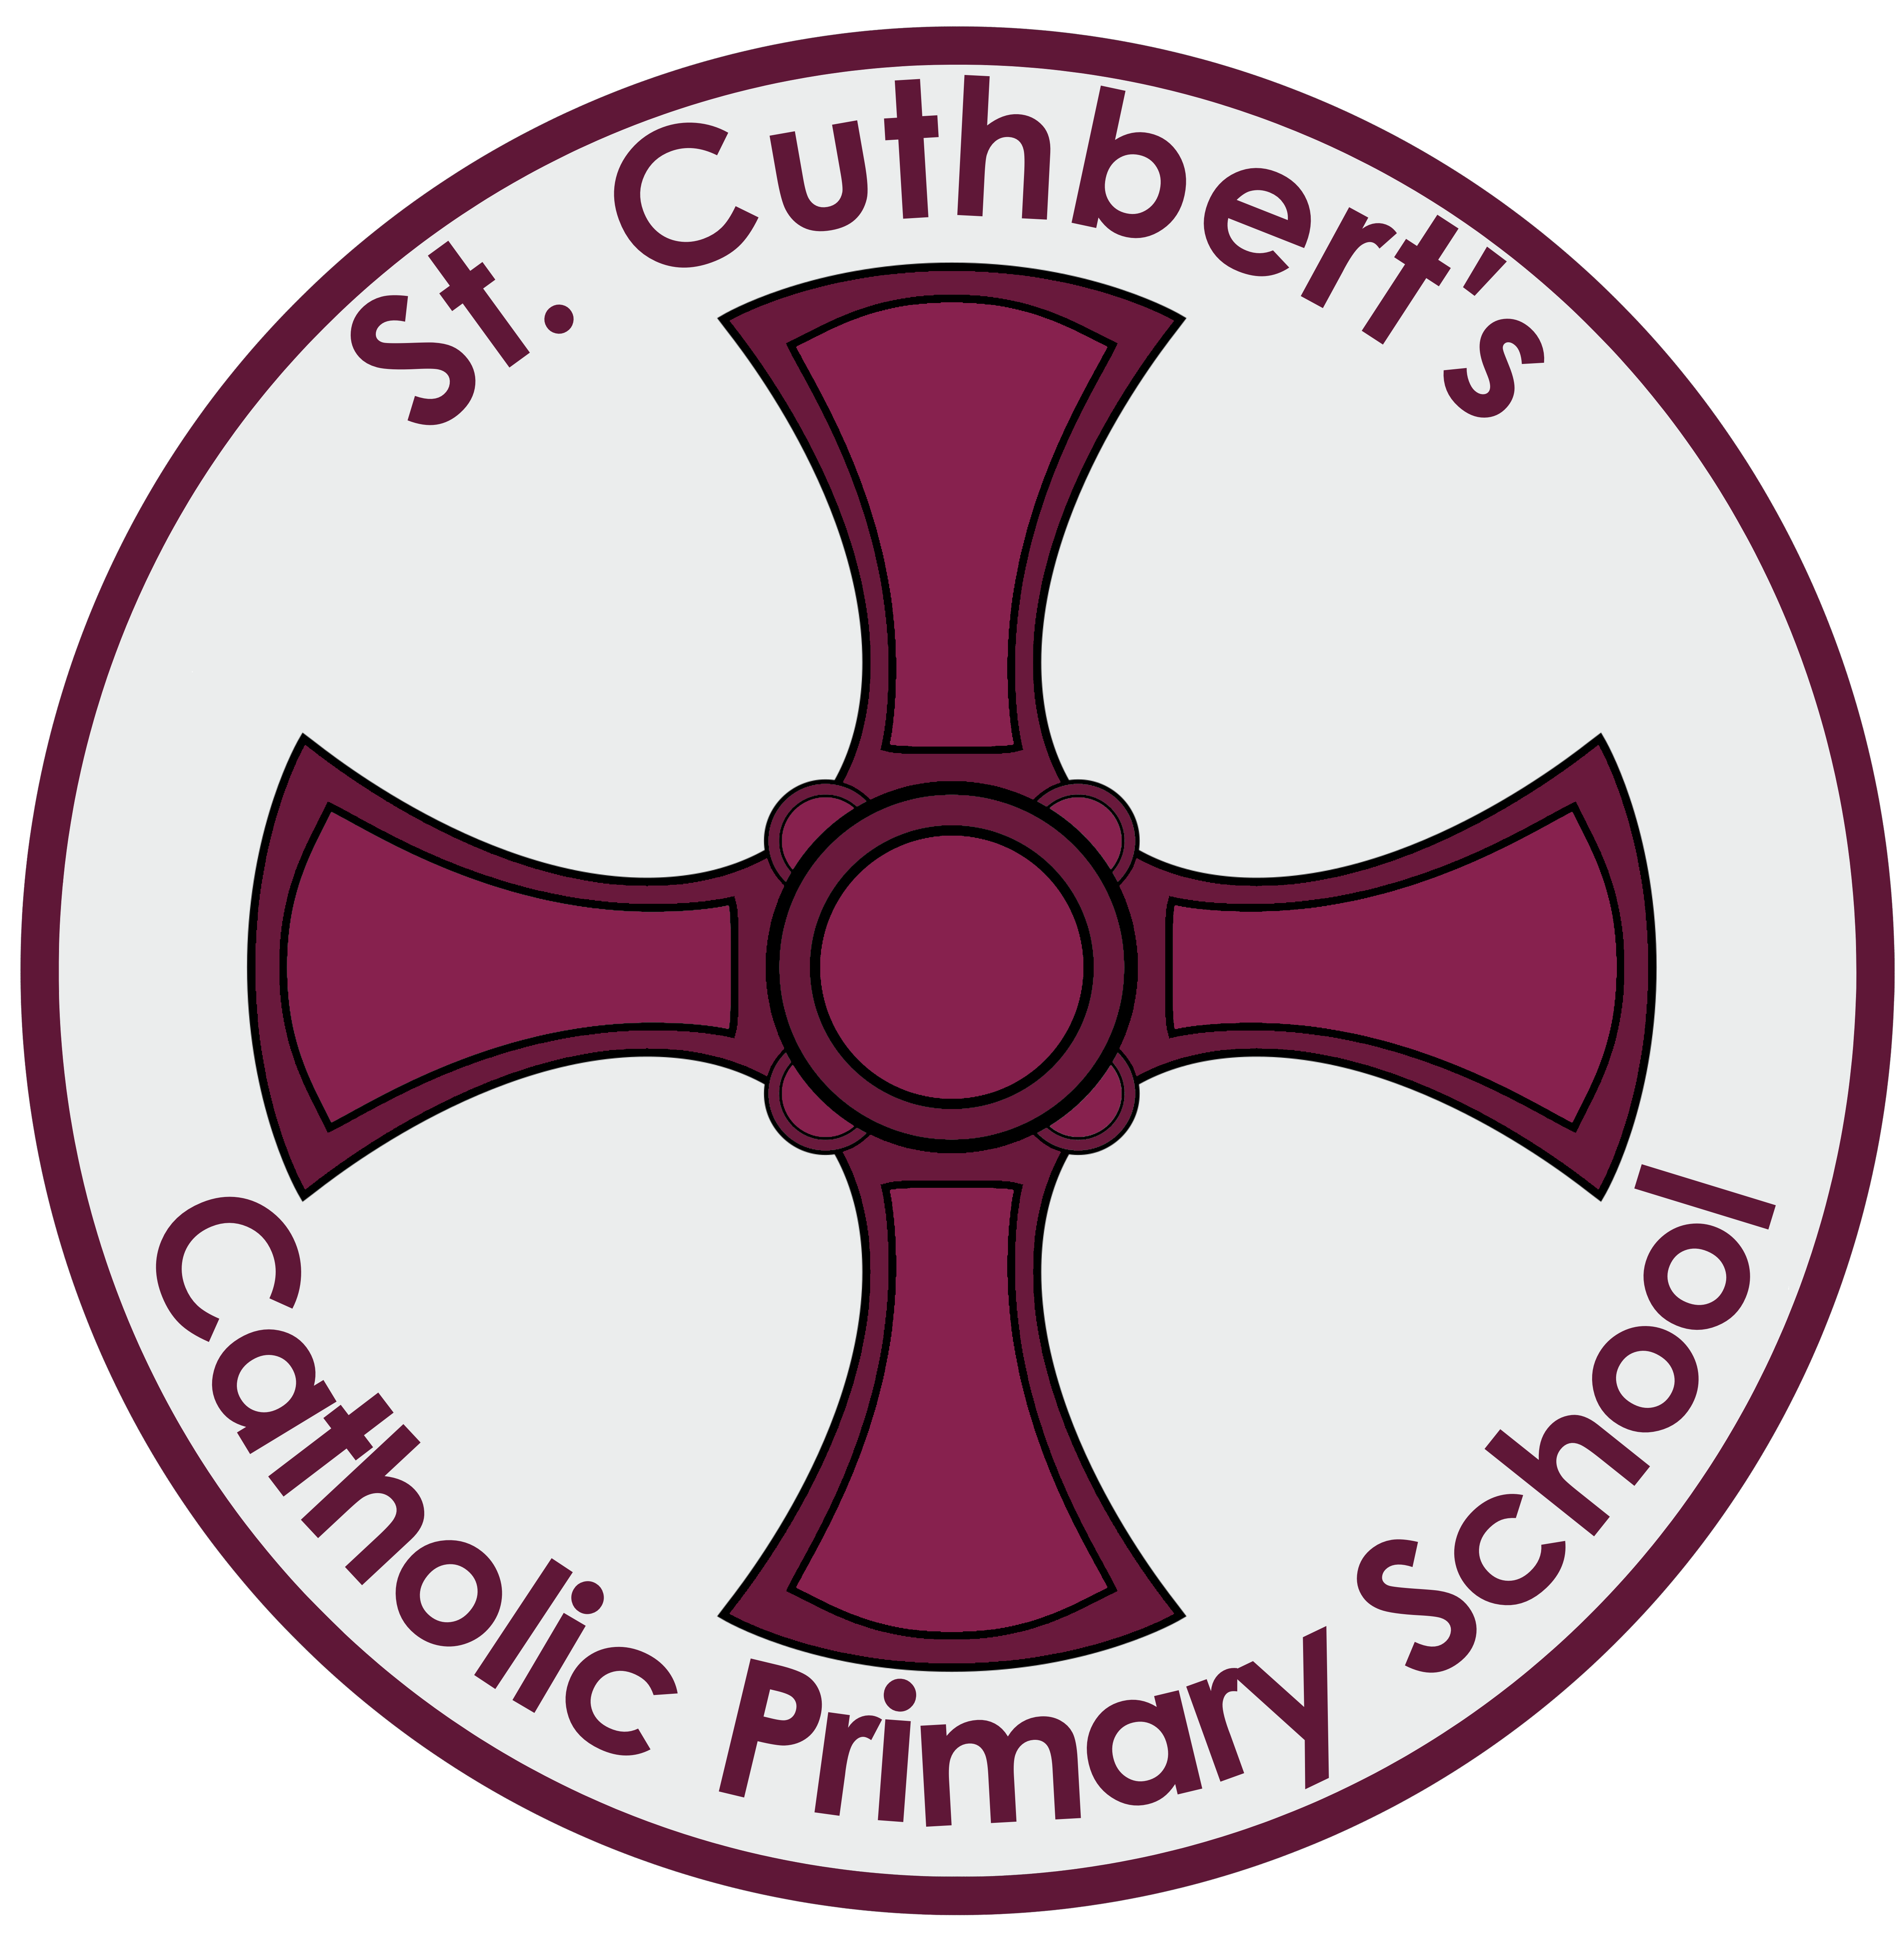
DURHAM COUNTY COUNCIL IN PARTNERSHIP WITH THE DIOCESE OF HEXHAM AND NEWCASTLE

St Cuthbert’s RCVA Primary School, Mill Road, Seaham,
Co Durham. SR7 0HW
Telephone No: (0191) 5813090
E Mail: seahamstcuthberts@durhamlearning.net

Headteacher: Mrs N J Noble

TEACHING POST
For September 2021 Full Time Class Teacher
Permanent contract - Pay Spine: Main Scale

The Governors of St Cuthbert’s wish to appoint a highly motivated teacher, enthusiastic and creative class teacher to join our dedicated staff.

What can we offer our staff?
- Enthusiastic, caring, well-behaved children
- A friendly, hard working and motivated staff, committed to the further development of our school.
- A supportive professional environment.
- Supportive Parents, Governors and Parish community.

KS1 Teacher (MPS)
We require a teacher with experience of Key Stage 1. We are looking for a teacher who
- is a committed, practising Catholic or is fully supportive of the Catholic ethos of our school.
- is an excellent classroom practitioner with high expectations of achievement and behaviour.
- is committed to raising standards within the curriculum.
- has high expectations of all pupils.
- is willing to contribute and work effectively as part of a team dedicated to school improvement.
- has a desire to create and engaging curriculum, full of learning experiences that the children will remember and be inspired by.

It is likely that this appointment will be for a Year 1 class.

Visits to our school in person or remotely are warmly welcomed and encouraged. Please contact the school office for an appointment.

The school is currently converting to become an academy and join Bishop Chadwick Catholic Education Trust. The Trust will be the employer for the successful applicant.
The governing body and the Diocese are committed to safeguarding and promoting the welfare of children and young people and vulnerable adults. The successful candidate will be required to undergo an Enhanced check for Regulated Activity for Disclosure and Barring Service.
Application packs are available from the school at the above email/address. Please ensure the application is made on a CES (Catholic Education Service) form. Applications not on the correct form will not be considered.
Closing date for receipt of applications: THURSDAY 20th MAY at 12 noon
Completed applications should be returned to the Head Teacher at the school address.
In the interests of economy, returned applications will not be acknowledged.

Closing date: 12:00noon Thursday 20th May
Shortlisting: Friday 21st May
Interview date: TBC

