History - Anglo Saxons

Monday 1st June
Your first task this week is to use vocabulary on the word mat below to do some online research into our history topic. You can record your learning in one of the books we sent home if you wish or you could use Word or Powerpoint if you have access to these. Try to include some labels, images and drawings if you want to. Try to list these alphabetically and include a glossary of terms.
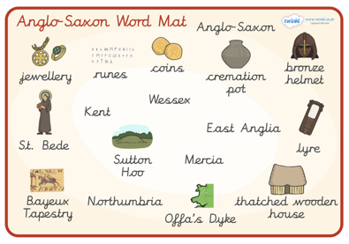

Tuesday 2nd June
Find out about theses runes and write your name out in runes.
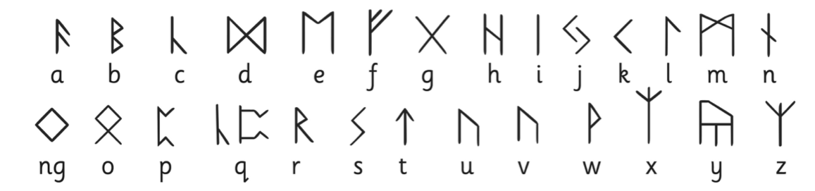

Now have a go at writing your own secret message and ask a family member to work out what it says.

Let me know how you get on!

