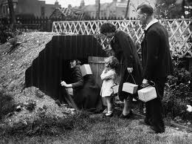

Each Anderson shelter holds 12 people. How many people could fit into 5 Anderson shelters?

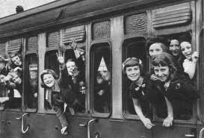
Each train carriage can hold 15 evacuees. How many evacuees will fit into 4 carriages?


Hannah decided to dig for victory. She planted 6 rows of carrots. Each row had 13 carrots in it. How many carrots did she grow altogether?

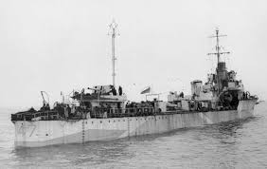

Navy destroyers held 23 sailors. If the British attacked the Germans with a convoy of 6 destroyers, how many sailors were on the boats in total?

A family of 14 are allowed rations of 3 pints of milk each per week. How many pints of milk do the family drink in a week altogether?

Nicola spent an average of 30 minutes per air raid in her Anderson shelter. How many minutes would she spend in her shelter if there were 4 air raid sirens in one day?

